EIS Action Research project

Exploring the impact of creating positive outdoor experiences on the parental attitudes towards accessing the local outdoors.

Konstantina Papaspyropoulou
Primary school teacher
Academic year: 2019/20

Abstract

The current action research project has focused on exploring the parental ideas on accessing the local outdoor spaces and the target of the intervention has been to promote the access to local outdoor spaces. The subjects of this action research project have been the twenty-five pupils of the Primary 3 class and their parents/carers. The stages of this project have been the following: identifying the parental ideas about the importance of being outdoors and accessing the local outdoor spaces, pupils’ engagement in outdoor activities and reflection upon them and sharing the positive experiences with their parents/carers, as a way of encouraging them to increase the frequency of visiting the local outdoors. Baseline questionnaires have been designed and distributed to the students of the class and their parents/carers. The pupils’ and parents/carers’ responses have determined the focus of this project. Even though it has been clear that the students of the class appreciate the importance of nature and being outdoors, they do not get many outdoor experiences out of school hours. Thus, the focus has been to explore the barriers that parents/ carers identify when it comes to accessing the local outdoors. Also, to explore whether the pupils’ positive experiences that take place in the school environment (communicated with parents/carers) have the potential to help individuals to overcome these barriers.

1. Introduction and Literature review
Research from within the UK’s education system suggests that “Contact with the outdoors is often limited for many children in modern society, and the vital experience of using the outdoors and being comfortable in nature is being lost” (L O'Brien, R Murray, 2006). The question that derives from this point of view is how we can set the foundation of a positive relationship with nature (if this is not already present) and how learning for sustainability can be promoted as a result of the development of a positive relationship with nature.
  - The “nature deficit disorder”.
The present action research project is structured around the concept of the nature deficit disorder. The first part of the literature review attempts to explore and review current research that focuses on the nature deficit disorder and to present the critique that it has been a subject to. In the current project when the term nature is being used, it refers to the local green outdoor spaces.
The nature deficit disorder, a term introduced by Louv (2006), is attempting to describe the lack of connection between the young people and the natural world and explore its implications on an environmental, social, psychological and spiritual level. According to Louv (2009), the term nature deficit disorder is not a medical term but a description of the growing gap between human beings and nature, with implications for health and well-being. When it comes to the development of a positive relationship between the children and nature, Louv (2009) emphasises the significance of the collaboration between the teachers and parents/carers, an idea that has been critical for the current research project. The importance of the nature deficit disorder is supported by Driessnack (2009) as the answer given to the the question of whether members of the paediatric domain should be aware of it is the following: even though the nature deficit disorder does not constitute an official diagnosis, it is important to be known by paediatric nurses. In the same report, Driessnack (2009), mentions various researchers who have identified and underlined the changes that children nowadays experience because they spend more time indoors rather than in outdoor spaces. One point underlined, is the fact that children are aware of global environmental issues through their education but simultaneously their knowledge of their local or even their garden’s ecosystem is restricted (Driessnack, 2009).
The term nature and the meaning it evokes when used in concepts such as nature deficit disorder, has been subject to critique by researchers. The appraisal that this concept has received, stems from the essence of the term nature itself and the place that humans have in relation to it. Fletcher (2017), pinpoints an oxymoron in the attempt to study the connection of humans with nature. Fletcher critiques the term of nature that humans have created as a social-cultural construction and its conceptualization will vary according to different contexts. The oxymoronic idea according to him is that environmental education activities intended to reconnect the people involved with nature, are suggesting that nature is both something separate from them and something of which they are part of (Fletcher, 2017). Argyrou (2004), explains that in order to have this point of view, from which, one can perceive the concept of nature, we must distance ourselves from the unity itself, which is a contradictory point of view if we consider that humans can be perceived as a part of nature. This action research project has used the term nature deficit disorder as a focal point and expression of the main problem. The attempt is to understand its implications to appreciate the significance of bridging the gap of children and outdoor experiences through education.
  - Benefits of outdoor experiences and learning.
According to the Play strategy for Scotland (2013), play promotes the development of social and collaboration skills and when children have access to natural spaces for play, it fosters a sense of close connection with and respect for nature. Moreover, open space allows children and young people to be physically active and challenge themselves so they sleep and eat well and form healthy habits that will stay with them for life. Also, the contact with nature and playing in natural spaces daily, has an impact on the use of these community green spaces as adults (Play strategy for Scotland, 2013). Dowdell, Gray & Malone (2011), have expressed the idea that access to the natural environment and reinforcement by a supportive teacher, offers to the pupils a richer environment for learning and promotes them to engage in natural play. The type of environment for play is also important and has an impact on children and young people’s experiences, choices, and relationships, both with other people and with the environment itself. Outdoor play, especially in natural spaces, is beneficial and provides experiences which cannot be replicated indoors (Play strategy for Scotland, 2013). Turcova, Neuman and Martin (2003), express that in order to be able to understand the impact of outdoor learning experiences fully, it is vital to develop the understanding of cultural, historical and geographical differences between concepts which are used in both English and non-English speaking countries. This understanding is important, as different approaches to outdoor learning depend on various other factors such as social, economic, cultural, or even demographic and political contexts according to O’Neil (2000) (Bentsen et al, 2009).
Bentsen, Mygind & Randrup (2009), present the example of Denmark which has developed the model of education outside the classroom, called udeskole. It is interesting to underline that udeskole does not refer only to a way of teaching but also a movement to redefine school and value outdoor experiences (Bentsen, Mygind & Randrup, 2009).
  - Parental contribution and concerns linked to local outdoor spaces.
According to Rouse (2012), the involvement and engagement of parents in their children’s education have long been recognised as an important contributor in enhancing outcomes for children. Also, it has been underlined that the dialogue between childcare providers and parents and informing them about the multifaced benefits of outdoor activities on a physical, social, and cognitive benefits of outdoor play opportunities has the potential to promote both groups’ value for active play (Rouse, 2016). When it comes to collaboration with parents there is an interesting point to be stressed regarding how teachers and parents approach collaboration. According to Tayler (2006), teachers perceive the collaboration with parents to build common understanding about the child. However, Hedges & Lee (2010), in their research examining parent perspectives have shown that it is the quality of the interpersonal communication between the teacher and the parent that is the barometer of how parents/carers evaluate the quality of the partnership. Jayasuriya, Williams, Edwards & Tandon (2016), explored the parental perceptions and knowledge of outdoor playtime in childcare environments. The main barriers that the parents express regarding their children engagement in outdoor activities are the following:
- Weather conditions,
- Child’s illness,
- Wearing weather appropriate clothing,
- Possible accidents.
A significant reason as highlighted by Evans (2000), is the fact that play areas for children such as traditional playground areas, streets, backyards are less accessible. Dowdell, Gray & Malone (2011), agree that the loss of outdoor play spaces has impacted the children’s opportunities to play. Moreover, adults’ involvement will affect the type of experiences that children have access to and how they approach new areas of knowledge. The role of teamwork between families and practitioners is a significant factor for quality planning and intervention and reflecting upon children’s well-being and involvement (Bento & Dias, 2017). According to Gill (2010), fears that parents have regarding accessing the outdoor spaces, are often brought by misinterpretations of reality, without having a real expression in society. For example, the fear about child’s abduction is not linked to an increase in these types of crimes, although a greater emphasis is given to these situations by social media. As Bento & Dias (2017) express, by promoting the development of positive outdoor experiences and by informing parents about the benefits of accessing the outdoors will eventually support the integration of these type of experiences in family routines. The development of strategies that allow parents to get involved in their pre-schooler’s daily activities, both indoors and outdoors, is important as they have the potential to support the parent–child bond and foster continued positive behaviours. Moreover, it is important to underline the fact that in 2016, Rouse highlights that there is a shortage of studies that have explored parental perceptions of outdoor play in early learning settings, something important as the understanding of the factors that families consider as barriers to experience the outdoors, can lead to a successful planning to change this reality.
  - Policy/ research about Scotland.
The action plan of the Play strategy for Scotland (2013), includes user friendly guidance for parents and carers on how to access cost effective resources for play and to build parents/ carers’ knowledge of various resources that can be used to encourage play at home and to help engage them in facilitating both indoor and outdoor play. Most children and young people will spend around 1500 hours of their life in their school playgrounds; for many this will be more than in any other outdoor play setting. Outdoor play does not necessarily mean visiting the local play park, sometimes it means playing kerby on the street or investigating local wildlife. The beauty of outdoor play is more than appreciating your natural surroundings and breathing in fresh air, it’s on your doorstep, it’s free and all children and young people can get involved – regardless of their background, gender, age, stage or ability, together with the whole family. The Curriculum for Excellence through Outdoor learning underlines the significance of the parental contribution. They are mentioned as key partners in delivering and preparing children and young people for outdoor learning experiences. Moreover, it is stated that parents and carers should be fully informed of planned visits in line with local procedures as well as being made aware of the educational benefits of ‘spontaneous’ visits. The element that is considered as fundamental is good communication between educators and parents/carers. It is important to support parents appreciate and understand the value of outdoor learning and ensure that children and young people are properly prepared in terms of clothing, food and what is required on the day. In Out to Play: Practical guidance for creating outdoor play experiences in early learning and childcare, outdoor learning experiences Improve learning for sustainability as they are developing a connection with nature and an understanding of environment and place as a child increases the likelihood of caring about these as an adult.

2. Research questions
The research questions for the current action research project have being formed around the initial interest on the nature deficit disorder and the parental contribution in the development of a positive relationship with the local outdoors. The methodology and research tools used in the current project are linked to the research questions or hypotheses and translated in a specific manner appropriate to the purposes of the study. According to Berelson (1971) there are five main sections to analyse a communication: the word, the subject, the persons, the measure of time or space and all the available material. The current study attempts to examine:
- Which are the barriers that parents/ carers have when it comes to accessing the local outdoors?
- Do the pupils’ positive experiences (communicated with parents/carers) have the potential to help individuals overcome these barriers?

3. Methodology
  - Mixed method approach
The current study has attempted to interpret the subjects’ experiences and find reasoning in both students and parents/ carers’ approaches. For this reason, following a mixed method approach has been identified as the most reliable approach. Paley (2000), expresses an unambiguous definition of both the qualitative and quantitative approach. Quantitative research presumes that there is an objective truth and a singular absolute reality. However, qualitative research perceives the reality as a place which is inherently subjective with no absolute reality (Paley, 2000).
The benefits of using quantitative research according to are briefly described below:
- prioritising numbers and figures in the collection and analysis of data,
- enables generalisation,
- reduce the researcher’s biases there is no direct contact with the participant (Paley, 2000).
The disadvantages that the author underlines are:
- the collected data will either support or reject the fixed paradigms,
- the researcher’s detachment from the subjects can be a disadvantage as it does not offer the opportunity for an in-depth investigation (Paley, 2000).
According to Robson (2002), the validity refers to whether the findings are "real" to what they appear to be. The generalisability refers to the extent in which the findings of the investigation are generally applicable, outside the specific conditions of the condition study (Robson, 2002). According to Cohen, Manion & Morrison (2011) in qualitative data collection the subjectivity of the participants, their ideas, attitudes contribute all together to a degree of bias.
  - Analysis/ Thematic analysis
Vaismoradi, Jones, Turunen & Snelgrove (2016), attempt to express a definition of thematic analysis. According to this definition thematic analysis and content analysis are both placed under the umbrella of the qualitative descriptive design. The idea that they are expressing is that their main characteristic is the systematic process of coding, examining of meaning and provision of a description of the social reality through the creation of theme (Vaismoradi, Jones, Turunen & Snelgrove, 2016). The analytical significance of the theme derives from the idea that the description of the process of theme development depends on the definition and clarification of the following:
- the meaning of the theme as a common point of reference and
- the understanding of the difference between the category and theme (Vaismoradi, Jones, Turunen & Snelgrove, 2016).
Hsieh & Shannon (2005) have provided a clear distinction between the category and theme as they express: a category is an idea that is directly expressed in the text, but a theme is more than a category. The benefit of this approach in the analysis of the data, is the inclusion of creativity and the involvement of researchers’ subjectivity in the different steps of theme development (Vaismoradi, Jones, Turunen & Snelgrove, 2016).
This study has chosen for the analysis of the data gathered a qualitative data analysis (thematic analysis) as it provides the capability to lead to the investigation of phenomena, processes and behaviours that were not anticipated in advance. Also, an advantage of qualitative analysis is the investigation characterized by detail and depth and performed exploration of the experience of social subjects.
  - Questionnaires
The quantitative part of the current action research project is the one regarding the perceptions of parents/carers towards accessing the local outdoors. The baseline questionnaires have been distributed to the parents/carers of this project in the beginning of the action research project. The categories of the baseline questionnaires are the following:
- Outdoor learning – The participants are asked to indicate how important they consider that learning in the outdoors is in education and how regular they think pupils should have access to outdoor learning experiences.
- Access to local outdoors – parents are asked to indicate to what degree being outdoors is an important aspect of child development and to what extend there are outdoor spaces accessible for them and their children in their local area. Moreover, parents are asked to say whether they are aware of the term “nature deficit disorder” and its implications.
- Frequency - in this section the parents/carers are asked to express the frequency in which their children access the local outdoor spaces.
- Sustainability - this area explores the parents/carers’ understanding and knowledge of the term sustainability and what it entails.
After the pupils experiencing the local outdoor spaces and the intervention ended, a second questionnaire has been distributed to the parents/ carers. The main categories have remained the same apart from a new category added. This category attempted to explore whether there has been a change in accessing the local outdoor areas compared to the initial responses on the baseline questionnaires. In detail, this area attempted to determine if the parents/carers appreciate that by developing a positive relationship with the outdoors can benefit the growth of respect for nature or if visiting the local outdoor spaces has increased or it is likely to increase in the near future.
The pupils have visited three outdoor areas that are located in the school’s local area. The demographic information of the students show that they are living in the school’s broader area, a fact that qualify these outdoor spaces as accessible. The students that participated in this project have been encouraged after visiting those local outdoor spaces to reflect upon their experience and discuss about them with their parent/ carer at home. This has been the key component of the current action research project as these experiences of the pupils, which have been mainly positive, were transferred to the parents.

4. Findings
4.1 Baseline questionnaires - Parents
The data gathered from the baseline questionnaires, regarding outdoor learning have shown that most of the parents/carers (71,4%) strongly agree that learning in the outdoors should be an important part of children’s education.
When it comes to how regular children should have access to outdoor learning experiences the 38% of the parents stated that they agree with this statement and 43% of the parents strongly agree. According to the access to the local outdoors, 62% of the parents stated that they strongly agree that accessing the outdoors is an important aspect of the child development.
The parents/carers have been asked to state whether there are outdoor spaces in the local area that their child or children have access to. Almost half of the subjects (43%) strongly agreed with this statement and 24% agreed. The 28,6 % of the subjects remained neutral in their statement (either agree or disagree) and two of the parents stated that they disagree. The participants who have either answered that they disagree or strongly disagree with the statement that in the local area there are outdoor spaces that their child/ children can have access to, have been asked to provide reasons that do not facilitate the access to the local outdoor spaces. Their answers expressed were related to the following areas:
- cleanliness, tidiness of the local outdoor spaces,
- outdoor “events” are not allowed in the area,
- only playgrounds are suitable for outdoor activities,
- the idea of children not allowed to play outdoors is interpreted as a stranger danger issue,
- lack of a variety of outdoor experiences.
Parental reluctance in allowing their children to access the local outdoors is an issue addressed in the Play strategy for Scotland. As outlined, avoiding the outdoors because of fear of traffic, concerns of personal safety or even the weather can impact on opportunities to play. Fears for children’s safety have at times resulted in restricted access to outdoor play. While the risks are real, the perception of them is often higher than the reality and should be balanced against the benefits of outdoor play. We know that learning to deal with challenges will help build children’s resilience into adult life (Play strategy for Scotland, 2013).
The data gathered in the first two parts of the questionnaire regarding the outdoor experiences and access to the local outdoor spaces have shown that the parents demonstrate a positive disposition towards their children experiencing learning outdoors or that they consider being outdoors an important element of their development. It is interesting to mention that the parents appear to appreciate the benefits of the exposure to the outdoors, despite that the fact they are not aware of the term of the “nature deficit disorder” and its implications. The next part of the baseline questionnaire has shown an inconsistency between the parents/carers’ disposition towards the outdoor local spaces and the frequency in which their children access the local outdoors. Almost a 30% of the parents strongly agree that their children access local outdoor spaces frequently, another 30% agrees with this statement and a 40% of the participants has remained neutral (either agree or disagree). Also, a 57 % of the parents have stated that their children have access to local outdoor spaces once a week and 24% daily. When it comes to sustainability most parents have remained neutral when asked whether they know what the term of sustainability covers and what the learning for sustainability covers. Despite this fact, 38% of the parents have expressed that they agree that access to the local outdoor spaces can promote their child’s learning for sustainability, whereas 33 % remained neutral. Little, Wyver & Gibson (2011) express that according to parents’ perceptions, factors in the environment limit opportunities for outdoor play and consequently challenging play. Also, they identified environmental hazards such as poorly maintained equipment or dangerous objects when it came to playground areas. Stranger danger was identified as a barrier (Little, Wyver & Gibson, 2011). According to Bento & Dias (2017), a way of supporting parents or carers to overcome potential fears or anxieties is the reassurance of the use of proper equipment for different weather conditions.
4.2 Baseline questionnaires – Students
A baseline questionnaire has been completed by the pupils in the class to investigate the pupils’ voice. The questionnaire covered the same categories as the parents’ questionnaire.
- 56% of the pupils believe that learning in the outdoors should be an important part of learning,
- 44% of the pupils stated that it should be a regular way of learning
- 72% of the pupils agreed that being outdoors is an important aspect of our physical and emotional development.
The part of the questionnaire exploring the access to the local outdoors and the frequency in which the students have access to the local outdoor spaces has shown that despite the parents’ statements 40% of the student experience the local outdoor spaces one a week, 12% daily, 8% once a month and 40% rarely. Moreover, 20% of the students expressed that they are aware of the local outdoor areas that they can have access to. The reasons that the pupils expressed cause the limited access to outdoor spaces in their local area are the following:
“maybe there are cars”,
“maybe there will be strangers”,
“maybe it is dangerous (it might have rocks)”,
“you need to be with an adult”,
“they are far away in the countryside”,
“your parents might not have money”,
“your mum wants to raise money, doesn’t want to pay”.
Only one pupil in the class has heard the term of sustainability and most pupils were able to express ways in which they can protect the environment. They have expressed ideas that derived from their learning for example, recycling, reduce the amount of carbon dioxide by walking to school, always put rubbish in the bins.
The findings of the baseline questionnaires have formed the focus of this project as the attempt has been to eliminate the barriers to accessing the local outdoor spaces by informing pupils for local outdoor space that the can access easily and cost free. The pupils have visited local outdoor spaces and engaged in stimulating outdoor learning experiences that after they have been asked to share with their parents/carers. Through sharing the positive experiences and promoting their parents/carers to access the local outdoors the attempt has been to see whether there has been any difference in this variable.
4.3 Outdoor experiences – reflection
Thematic analysis
The pupils that participated in this action research project had access in outdoor learning activities as a part of our school’s active learning stations, which took place twice a week. The outdoor activities took part in the courtyard area that the establishment offers. The pupils were asked to reflect upon two of these experiences and to share their ideas with their families. Seventeen (out of 25 students) have reflected upon their experiences.
The local outdoor spaces selected for this action research project are three in number. The pupils can have quick access to these outdoor spaces without any travel costs. After visiting two of the local outdoor spaces selected for this project, the pupils have been asked to reflect upon their experience and to share their experience with the rest of their parents/ carers. The answers gathered have been 17 out of the 25 students.
The analysis of the pupils’ answers has shown that there are four themes deriving from their experiences. It is important to mention that the pupils have expressed positive experiences about being outdoors. Eighteen students out of the twenty-five pupils have reflected upon their experience and discussed about it with an adult.
The themes identified in the students’ reflection on the outdoor experiences are the following:
Experiencing the natural elements
“I like when the rain touches my head, it is beautiful, wonderful”,
“I like the fresh air”,
“Today I enjoyed stepping in mud because it is part of nature and it is squishy and feels like rain on my feet including the activities”.
Being active/ exercising
“It is good for your body, the running”,
“I love going outside because it is fun when we run”.
Play
“I like the adventure because it was fun”,
“I enjoyed the most playing with my friends”.
Weather conditions
“It’s good outside when its summer I will go outdoors”,
“The weather does not stop you even if it is raining it still doesn’t stop you going to the nature”.
Bento & Dias (2017), present the benefits of outdoor play in the following three categories: the importance of risk, contact with the natural elements and socialisation opportunities. They stress the benefit of outdoor play in relation with the child’s physical development, engaging in physical activity and experiencing the natural elements. The students in the current action research project have mentioned the element of adventurous play, a notion that probably includes taking risks and being challenged. According to Little, Wyver & Gibson (2011), risky play might be defined as play that provides opportunities for challenge, testing limits, exploring boundaries, and learning about injury-risk (Ball 2002; Little and Wyver 2008)
Pupils’ local outdoor areas map
The pupils have engaged in interdisciplinary activities that allowed them to research about each one of the local outdoor spaces selected and visited have created a “map” that included information and has been used as a means of encouraging their parents to visit more frequently those areas. Below is the map that the pupils have created.
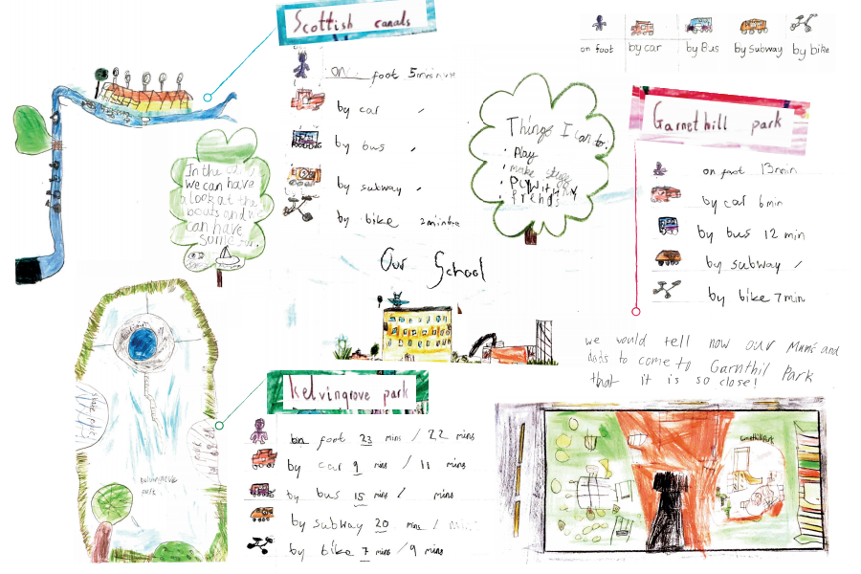
Picture 1.1
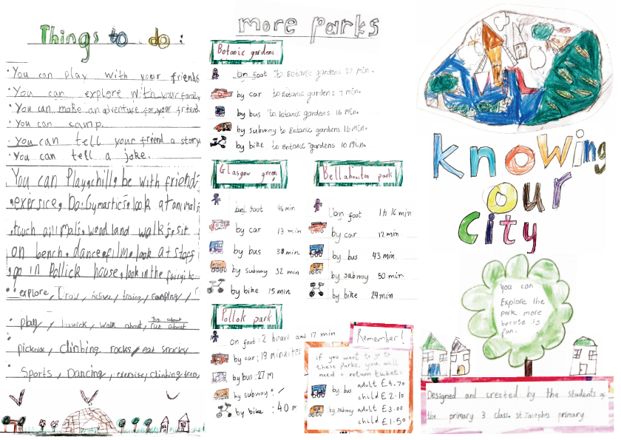
Picture 1.2

4.4 End of project survey
The questionnaires at the end of this action research project have been distributed online and the parents/carers have been invited to take part in this survey via an email. It is important to mention that this step of the action research project took place during the lockdown period due to COVID-19. Due to the changes that this unexpected situation has introduced, five participants have been able to take part in this final section of the project.
The results have shown that the parents agree or strongly agree with the importance of outdoor experiences and that it is a significant factor of the development of the child’s health and well-being. All five parents/carers that participated in the end of the project survey are aware of the local outdoor spaces that they can have access to, and they have learned through this intervention a new local outdoor area. All the parents agree that by developing a positive relationship with the outdoors can benefit the growth of respect for nature. Finally, they are positive that after this experience, visiting the local outdoor spaces has increased or it is likely to increase in the near future.
- Discussion
Outdoor play opportunities are needed at all ages and stages as a frequent part of family life. As children grow older, they need opportunities to develop independence through playing outdoors, helping to develop and practice important life skills within the real world (Bento & Dias, 2017). As it has been mentioned in the literature review of the current project, the quality of communication between the school setting and families is fundamental, as it can inform the later about the benefits of accessing the local outdoor spaces and allow children to develop positive experiences in the outdoors. Moreover, according to the current project, a factor that can affect the access to the local outdoor spaces is the lack of knowledge of these spaces by parents/carers and concerns that they have related to allowing the children visiting these areas. By encouraging the students to develop a positive relationship with the local outdoors and transfer this knowledge to their families could affect the way parents/cares perceive the access to the local outdoor spaces. The current action research project has offered the opportunity to identify the parental attitudes towards outdoor experience, a fact that offers a starting point for building on the development of a positive relationship with the local outdoor spaces. The circumstances in which the project has taken place, have affected the final part of this study. However, acknowledging the parental attitudes towards accessing the local outdoor spaces and exploring the pupils’ reflections, has offered a baseline for future learning in this area of interest.

Appendix
Picture 1.1
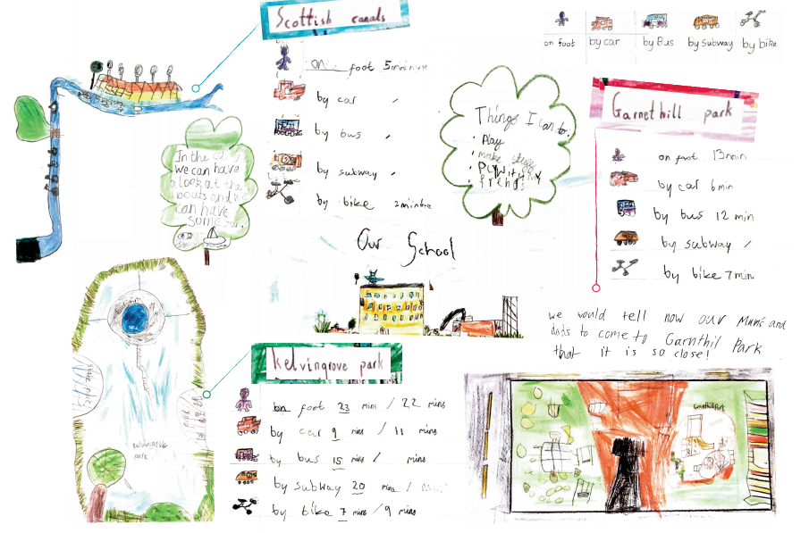

Picture 1.2
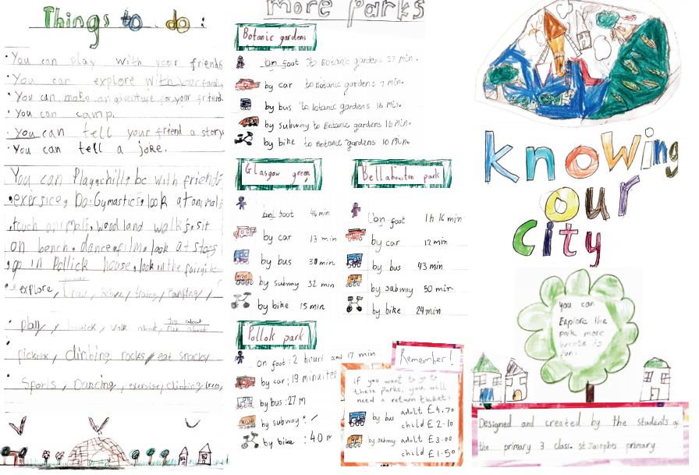
References
Argyrou, V. (2004). The logic of environmentalism: Anthropology, ecology, and post coloniality. New York, NY: Berghahn.
Berelson, B. (1971) Content analysis in communication research. New York: Hafner Publishing Company.
Bento, G., & Dias, G. (2017). The importance of outdoor play for young children's healthy development. Porto Biomedical Journal, 2(5), 157-160.
Bentsen, P., Mygind, e., & Randrup, T. (2009) Towards an understanding of udeskole: education outside the classroom in a Danish context. Education 3–13, 37:1, 29-44
Cohen, L., Manion, L. & Morrison, K. (2011) Research methods in education. Abingdon, Oxon [England]: Routledge.
Dowdell, K., Gray, T., & Malone, K. (2011). Nature and its influence on children’s outdoor play. Journal of Outdoor and Environmental Education, 15(2), 24-35.
Driessnack, M. (2009). Children and nature-deficit disorder. Journal for Specialists in Pediatric Nursing, 14(1), 73.
Education.gov.scot. (2010). Available at: https://education.gov.scot/Documents/cfe-through-outdoor-learning.pdf
Evans, J. (2000). Where do the children play? Children Australia, 25(2), 35-40.
Fletcher, R. (2017) Connection with nature is an oxymoron: A political ecology of “nature-deficit disorder”, The Journal of Environmental Education, 48:4, 226-233, DOI: 10.1080/00958964.2016.1139534
Gill, T. (2010) Sem medo: crescer numa sociedade com aversão ao risco. Cascais: Princípia.
Hedges, H., & Lee, D. (2010). I understood the complexity within diversity: Preparation for partnership with families in early childhood settings. Asia – Pacific Journal of Teacher Education, 38(4), 257–272.
Jayasuriya, A., Williams, M., Edwards, T., & Tandon, P., (2016). Parents’ Perceptions of Preschool Activities: Exploring Outdoor Play, Early Education and Development, 27:7, 1004-1017, DOI: 10.1080/10409289.2016.1156989
National Foundation for Educational Research in England and Wales, & Dillon, J. (2005). Engaging and learning with the outdoors: The final report of the outdoor classroom in a rural context action research project.
O'neill, J. (2001). Building better global economic BRICs.
Little, H., Wyver, S., & Gibson, F., (2011). The influence of play context and adult attitudes on young children's physical risk‐taking during outdoor play, European Early Childhood Education Research Journal, 19:1, 113-131, DOI: 10.1080/1350293X.2011.548959
Louv, R. (2006). Last child in the woods: Saving our children from nature-deficit disorder. Chapel Hill, NC: Algonquin Books of Chapel Hill.
Louv, R. (2009). Do our kids have nature-deficit disorder. Educational Leadership, 67(4), 24-30.
O’Brien, L., & Murray, R. (2006). A marvellous opportunity for children to learn. A participatory evaluation of Forest School in England and Wales. Surrey: Forest Research.
Robson, C. (2002) Real world research: A resource for social scientists and practitioner-researchers (Vol. 2). Oxford: Blackwell.
Rouse, E. (2016). Making learning visible–parents perceptions of children's learning outdoors. Early Child Development and Care, 186(4), 612-623.
Tayler, C. (2006). Challenging partnerships in Australian early childhood education. Early Years. Journal of International Research & Development, 26, 249–265.
Turcova, I., J. Neuman, and A. Martin. 2003. The outdoors from a Czech perspective. Horizons 24: 26–9.
Paley, J. (2000). Paradigms and presuppositions: the difference between qualitative and quantitative research. Research and Theory for Nursing Practice, 14(2), 143.

Scottish Government. (2013) Play strategy for Scotland: our action plan. Available at: https://www.gov.scot/publications/play-strategy-scotland-action-plan/

Sottish Government (2020). Out to Play - creating outdoor play experiences for children: practical guidance. Available at: https://www.gov.scot/publications/out-play-practical-guidance-creating-outdoor-play-experiences-children/

Vaismoradi, M., Jones, J., Turunen, H., & Snelgrove, S. (2016). Theme development in qualitative content analysis and thematic analysis.

